 Pangani Basin Water Board 
Hydrological Bulletin March 2026
2025

RAINFALL TRENDS
The month of March bore all the typical hydrological conditions of wet season in the basin. Rainfall events were registered in the very start of the month between the first and the third day especially around the slope areas of Mount Kilimanjaro. Three stations (Tengeru, Lomwe na Hale plantation) rainfall stations out of 15 sampled rainfall stations recorded rainfall above 1000mm rainfall in the month of March. The figure below shows the monthly variation of rainfall in 15 sampling stations.
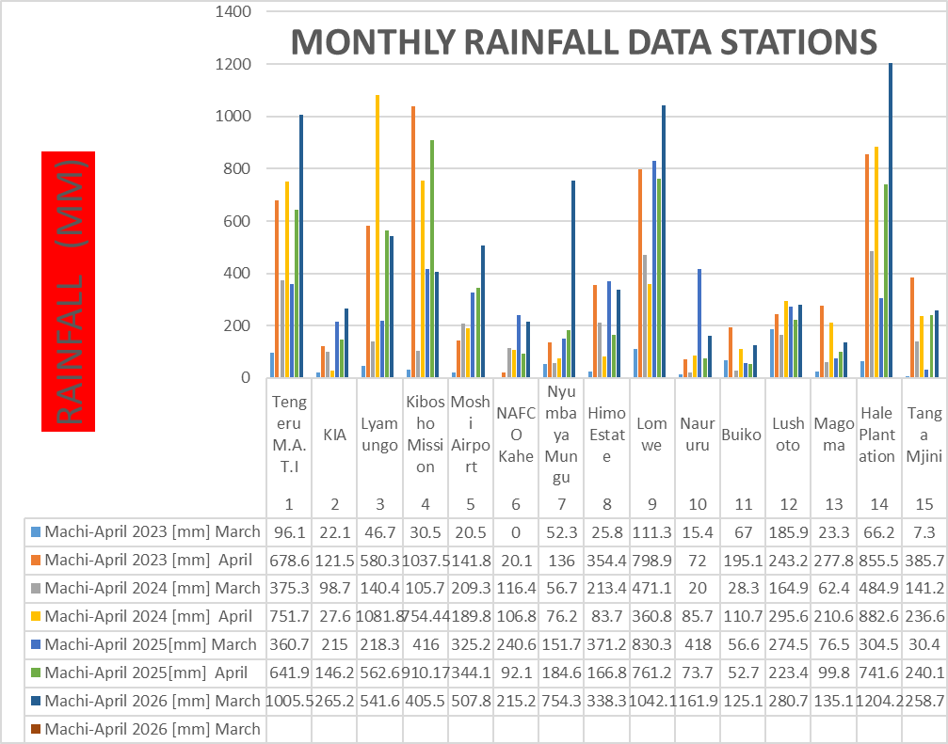

RIVER FLOWS AND DAM LEVELS
As it was expected in the end of the last month, the flow for both rivers were rising higher and higher above their monthly averages. Within the last 15 years, the month was the second wettest for Zigi (figure 5) and Kikuletwa (figure 3) river while being the third and fourth for Ruvu (figure 4) and Pangani (figure 6) rivers respectively. Water level of Nyumba ya Mungu (figure 7) reservoir was continued to be critically above monthly normal at week 5 of the year with the recording of 689.07m.a.s.l and meanwhile the spilling starts. Water level of Mabayani reservoir was also above average with monthly average of 4.263m corresponding to 90.824 m.a.s.l (figure 7).
- Flows hydrographs for selected rivers (from March 2026)
Figure 3: Kikuletwa River | Figure 4: Ruvu River
Figure 5: Zigi River | Figure 6: Pangani River (Korogwe)
- Water level hydrographs for reservoirs
Figure 7: Nyumba ya Mungu Reservoir | Figure 8: Mabayani Reservoir

- Conclusion
The water resource outlook continues to be healthier and good in the Basin. Rivers flows continue to rise, an indication that the groundwater has been sufficiently recharged. However, rivers flows will continue to rise considerably above average due to the fact that we expect to receive as much as rainfall in the next month which is still the long rain season. It is expected that there won’t be threats related to scarcity of water within the basin but rather, floods may occur in some parts of the basin due to continued improvement of the river flows. Water levels of reservoirs will also continue to be higher than their monthly averages.

